MCP Report Manager Tutorial

GETTING STARTED
MCP Report Manager can be opened from the Start Menu or by using the desktop icon. There is a list of reports in the top left corner of the window. Selecting one of the reports will bring up that specific report’s options in the area to the right. The user can toggle between reports at any time.

MENUS
Options: Here the user can set their preferences. This includes two fields, network cache location (R: drive) and local cache location (user’s computer). These will default to the correct location upon installation and should only be changed by the network administrator.

Tools:
This provides a different means to selecting a report. If the user prefers to select the report from the drop down menu, they may. An easy alternative is using the radio buttons in the left panel.

Help:
“About” will give information on the program along with the software version number. “Tutorial” will link you to this file.

DATA SOURCE OPTIONS
MIS and Holdings Reports
These two reports have the same data source options, shown below.

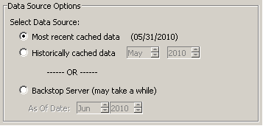

The first two options, “Most recent cached data” and “Historically cached data,” use data stored on the R: drive. Generating a report from this data source is much faster because the program does not need to retrieve the information from Backstop’s server.

Most recent cached data:
This option uses data for the most recent period specified in parentheses to the right. For both the MIS and Holdings Summary reports, this date is defaulted to the month of the last balance upload. For the Statistics Report, this date is simply the month prior to the current date.

Historically cached data:
This option allows the user to select the date to run the report. The dates in this list will only appear if there is a valid cache for that date.

Backstop Server (may take a while)
This option retrieves data directly from the Backstop server allowing the user to get the most up to date data. This is convenient if new changes were made to the server since the caches were updated (reference update schedule below).

Statistics Report
The statistics report data options are slightly different than MIS and Holdings Summary data options. They are shown below.

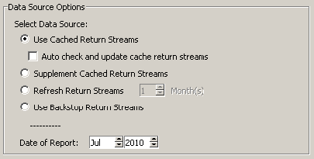

Instead of caching the data as it would appear just before output, the statistics caches are designed to save the return streams of each fund along with other information pertinent to each manager. This enables rapid report generation for any combination of funds for any time period.

Use Cached Returns Streams:
Selecting this source with obtain fund return streams directly from the cache without doing any cross referencing with Backstop for existing cached funds. If there is no data in the caches for a given fund, it will be automatically retrieved from Backstop. This option is best when updates to fund returns in Backstop are not being made often.

Auto Check and Update Cache Return Streams:
Checking this option will automatically check for discrepancies between cached data and Backstop and correct any differences. If this option were not selected, the “Check Returns” button, discussed later, will reveal any discrepancies. To correct those discrepancies, use the “Supplement Cached Return Streams” option.

Supplement Cached Return Streams:
This option cross references Backstops data with the cached data and automatically resolves any discrepancies. This option is ideal when returns have been entered into Backstop but the automatic cache process may not have occurred yet (i.e. the beginning the month).

Refresh Return Streams:
If the user chooses this option, fund returns will be refreshed (either overwritten or added to the cached data from Backstop) for the number of designated months. For example, if three months were chosen, it would refresh returns for the most recent three months.
Use Backstop Return Streams:
This option will go to Backstop and retrieve completely new data for the report generation.

Date of Report:
The date of the report will specify the base date for the trailing periods.

NOTE: With every data option, if Backstop is being accessed, it is only getting information for the funds selected from the GUI.

CACHING SYSTEM
Caching is a means to storing information. For this program, caching is done to decrease report generation time as most of the time it takes to create the report is attributed to retrieving information from the Backstop server. The caching system retrieves the information needed for the reports from Backstop, manipulates the data, and then saves it just before the outputting and formatting process would begin. When generating a report from the cache, the program can simply load the information and immediately begin outputting it to the PDF or Excel file.

For the statistics report, whenever Backstop is accessed to get new information, the network caches are updated, so the data retrieval from Backstop can benefit everyone.

Meridian’s server automatically updates the caches on the following schedule. If the updates are daily, weekly, or monthly, they are done in the middle of the night.

Statistics Report:
Most Current Month Hourly
Additional Managers List Hourly
Custom Peer Group Manager List Hourly
Past Year of Archives Daily
All Archives Monthly

MIS / Holding Summary Reports:
Most Current Month Every 12 Hours
Past Year of Archives Weekly
All Archives Monthly

The caches are also checked to make sure files have not become damaged or deleted. This is done on a daily basis. Historical archives begin on 1/1/2004.

MIS REPORT OPTIONS
For reference, the MIS Report options, as they appear in the program, are shown below.

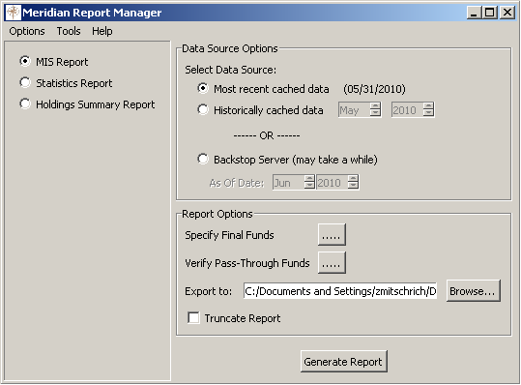

Specify Final Funds:
This option designates which funds will be displayed in the report. Changing the funds selected here does not affect the allocation of holdings.

Verify Pass-Through Funds:
This option designates which funds are SPVs (or SPV like entities). This option should only be changed when the Meridian fund structure is altered.

Export to:
This field defaults to the desktop. However, if the user would like to save the document to a different folder, simply click “Browse…” to select a new directory.

Truncate Report:
Selecting this option ensures that each fund’s summary fits on a single page. This is done by cutting the oldest information for Meeting History, AUM Info, and Quarterly Exposures sections of the report.

STATISTICS REPORT OPTIONS
For reference, the Statistics Report options, as they appear in the program, are shown below.

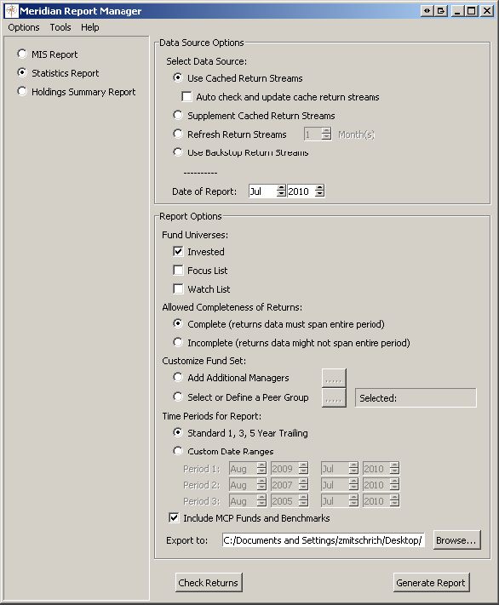

Fund Universe:
Select the fund universes for the report. These universes are pulled from Backstop using a Fund Builder. In order for a fund to be included a universe, its Interest Level field must be either “Invested,” “Focus List,” or “Watch List 1” and the Part of PMG Binder field must be “Yes” for both invested and focus list funds. If the report includes more than one universe, invested funds will appear in blue, focus list funds in black, and watch list funds in purple.

Allowed Completeness of Returns:
This option specifies how to handle funds that do not have returns over a full period. By selecting “Complete,” only funds with complete returns for a period will show up on the report and the “MRR” (most recent return) column will be hidden. If “Incomplete,” is selected, all funds are included in the report and the “MRR” column will be shown. Those funds with incomplete returns will be italicized. The funds excluded from the report will be listed on the “Notes” worksheet. If a fund does not have returns through the start date of a period, it will be excluded for that portion of the report.

Note - The date of most recent return in this report may not be the same as the “Date Of Most Recent Return” field in Backstop. The date used in this report includes estimated returns whereas the Backstop field does not.

Customize Fund Set:
This option allows the user to add additional managers to the fund universe or create a report for a peer group.

- Add Additional Managers
For reference, the Add Additional Managers window, as it appears in the program, is shown below.

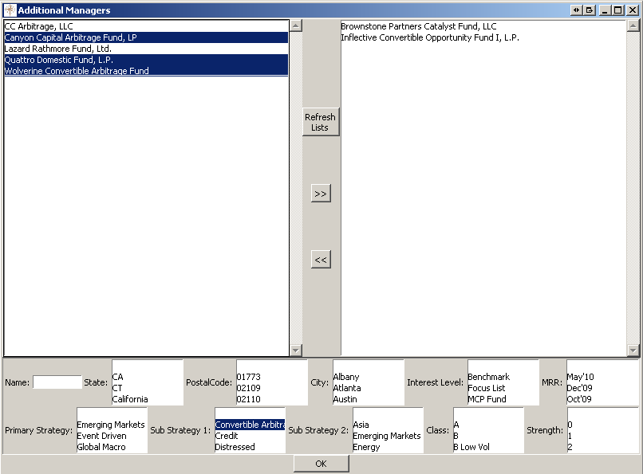

When the list first appears, it is sorted first by date of most recent return and then alphabetically. The list automatically removes the managers of the selected universe to avoid duplicates in the report. The user can search for funds by name any of the fields on the bottom. To “update” the list with the filter options, hit the enter key. Funds can be selected and deselected using the arrows in the median. The funds in the right pane will be the ones added to the fund universe. The names of the additional funds will be red in the report.

In case a fund was just added to backstop, the user can press the “Refresh Lists” button to update the list of managers shown in the left panel. This may take a few minutes.

- Select or Define a Peer Group
For reference, the Peer Groups window, as it appears in the program, is shown below.

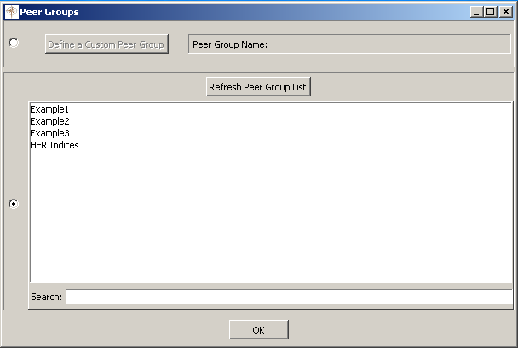

The user can either define their own peer group from a list of all funds in Backstop or select a pre-defined Backstop peer group. The name of the selected peer group will appear to the “Selected:” box in the main window. If the user chooses to create a custom peer group, they add managers to a list in a similar manner when adding additional managers to the fund universe. A name for the peer group must be provided. If none is given, the user will be prompted to do so. Also, the custom peer group can be saved to Backstop by selecting the appropriate option at the bottom of the window.

In case a fund was just added to Backstop, the user can press the “Refresh Lists” button to update the list of managers shown in the left panel. This may take a few minutes.

If the user chooses to use a pre-defined peer group, they can search and select from the list provided. The list of peer groups is generated from all the peer groups from Backstop. However, only those with “{Stats}” as a prefix in their name will show in this program. Pre-defined peer groups are cached.

Like the manager lists, the user can refresh the peer group list as well by pressing the “Refresh Peer Group List.” This may take a few minutes.

Time Periods for Report:
The report can be generated using the standard trailing periods or custom date ranges. The trailing periods are defined depending on the date selected in the Backstop Server option. The custom date ranges reflect the standard trailing periods by default.

Include MCP Funds and Benchmarks:
This option specifies whether to include the MCP Funds and Benchmarks section at the end of the report. The funds / indices included are Meridian Capital Fund LLC - 1%x10%, Meridian Performance Partners L.P. – A, ML 90-Day US T-Bill, and S&P 500 TR.

Export to:
This field defaults to the desktop. However, if the user would like to save the document to a different folder, simply click “Browse…” to select a new directory.

Check Returns:
Pressing this button will cross reference Backstops information and reveal any discrepancies. If the “Auto check and update cache return streams” option is selected, this window will instead of showing the discrepancies, simply correct them automatically. Additionally, this window will display funds whose MRR is not the same as the date of the report (i.e. a preview of the “Notes” page).

Excel Macros:
Once the report is generated, a dialogue box will appear allowing the user to sort the report by a certain statistic. This dialogue box can reappear at any time by pressing Ctrl-Shift-S. Rankings for each fund’s statistic can be generated as well. To do this, press Ctrl-Shift-R. A message box will appear letting the user know when the process is complete. All the columns added for the rankings will be hidden and the report will appear as it did before you calculated the rankings. Simply unhide the column to the left of a statistic to see the rankings.

HOLDINGS SUMMARY REPORT OPTIONS
For reference, the Holding Summary Report options, as they appear in the program, are shown below.

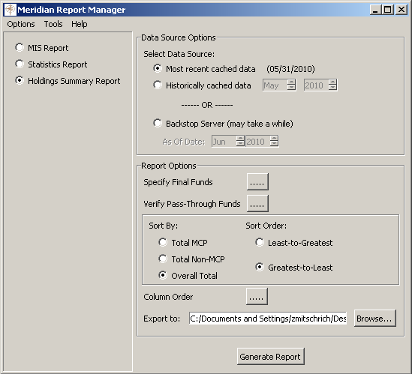

Specify Final Funds:
This option designates which funds will be displayed in the report. Changing the funds selected here doesn’t affect the allocation of holdings.

Verify Pass-Through Funds:
This option designates which funds are SPVs (or SPV like entities). This option should only be changed when the Meridian fund structure is altered.

Sort By:
The management firms in the report will be sorted by the option selected.

Sort Order:
The management firms in the report will be sorted by the option selected.

Column Order:
The user can change the order that Meridian’s funds appear in the report. The default mimics the order of funds in the PMG binder.

Export to:
This field defaults to the desktop. However, if the user would like to save the document to a different folder, simply click “Browse…” to select a new directory.

